Digital Lab 5:

Seven-Segment Display

Date: 2023/04/19

Class: 電機二全英班

Group: Group 8

Name: B103105006 胡庭翊

B103015018 劉姵妤

1. Purpose of the experiment
   1. Understand the operation of the seven-segment display.
   2. Apply the acquired logic circuit design skill to appropriately implement the functionality of seven-segment display.
2. Function of the circuit

Design a circuit using logic gates and seven-segment display to correctly display the letter and digits of one of the member’s student ID:

B103015006 = {b, 0, 1, 3, 5, 6}

1. Description of each step of the experiment
   1. Analyze the seven-segment display
      1. Seven-segment display is consisted of 8 LED, each of them is labeled in a designated pattern from ‘A’ to ‘F’, and the dot is labeled as “DP” to indicate the decimal point as the figure below shown.

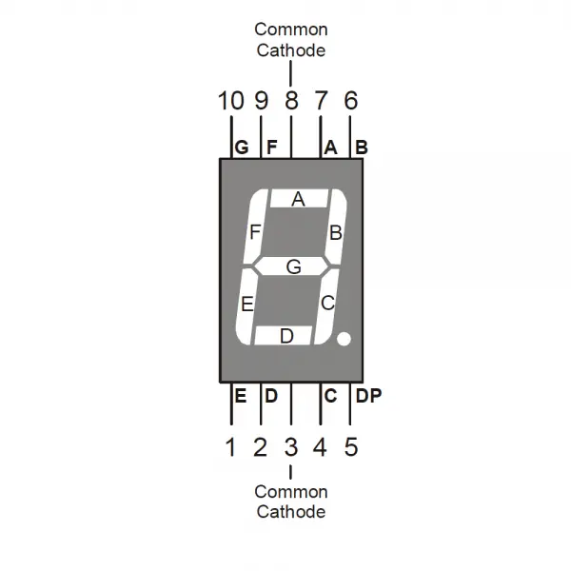

* + 1. The seven-segment display we used in this lab is the common-cathode type (LT503), which designates that each port of the LEDs need to be connected to high voltage level to make the LEDs work in positive bias, while the3 and 8 ports are grounded at all time.

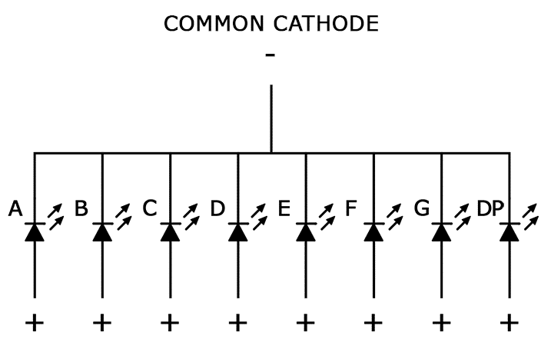

* 1. Draw the K-maps referred to the output
     1. Each segment of the display is viewed as a single output, resulting that seven K-maps is needed for simplifying the inputs of each segment.
     2. In this case, characters b,0,1,3,5,6 are designated to be display correctly, which means that when the dip switch inputs the signal(A,B,C,D)=(0,0,0,0), (0,0,0,1), (0,0,1,1), (0,1,0,1), (0,1,1,0), (1,0,1,1) should lead to their corresponding output 0,1,3,5,6,b, while other inputs are not cared.
        1. K-map of Segment A

Segment

* + - 1. K-map of Segment B

Segment

* + - 1. K-map of Segment C

Segment

* + - 1. K-map of Segment D

Segment

* + - 1. K-map of Segment E

Segment

* + - 1. K-map of Segment F

Segment

* + - 1. K-map of Segment G

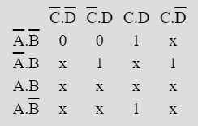

Segment

* 1. Circuit design
     1. Circuit diagram一張含有 圖表, 圖解 的圖片

        自動產生的描述
     2. Function of the circuit
        1. 一張含有 圖表 的圖片

           自動產生的描述
           1. Switch
           2. When the switch is open, high-level voltage would become the input of the corresponding bit.
           3. When the switch is close, the terminal of the circuit would connect to the ground, low level voltage would be the input of the corresponding bit.
        2. Output

* + - 1. Output

* + - 1. Output C = 1
      2. Output

* + - 1. Output

* + - 1. Output 一張含有 圖表 的圖片

         自動產生的描述
      2. Output G = C+B



* + - * 1. Port 3 and 8 are common.
        2. Other ports connect to each corresponding output to protect the circuit, and an extra resistor set between the output and the seven-segment display.
        3. Port 4 is connected to the high voltage level.
  1. Result

According to the student ID B103015006, decimal numbers 0,1,3,5,6 and character ‘b’ as inputs are designated to show the correct number on the seven-segment display, which is 0000,0001,0011,0101,0110,1011 in binary.

* + 1. (A,B,C,D)=(0,0,0,0)

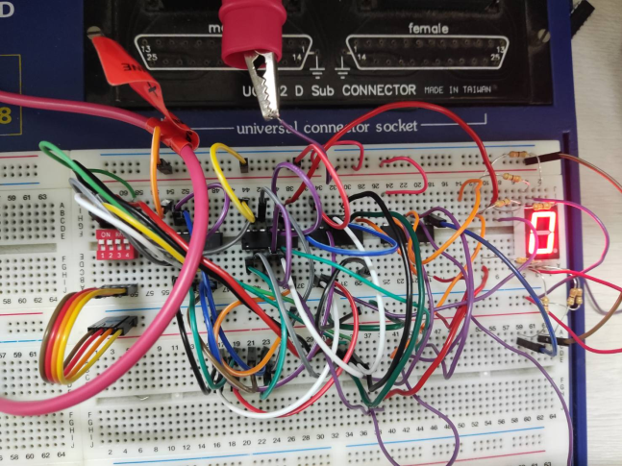

* + 1. (A,B,C,D)=(0,0,0,1)

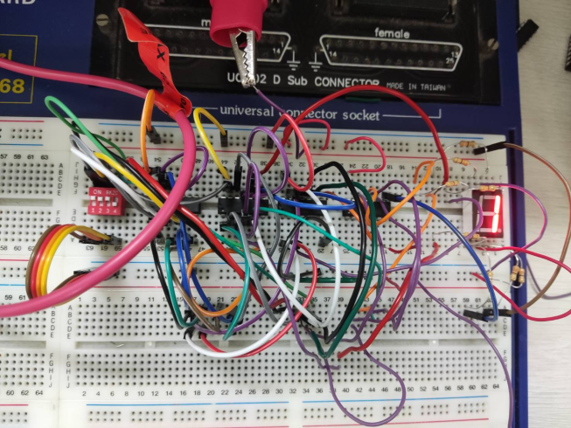

* + 1. (A,B,C,D)=(0,0,1,1)

* + 1. (A,B,C,D)=(0,1,0,1)

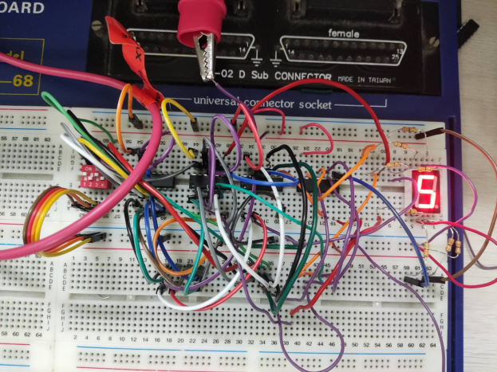

* + 1. (A,B,C,D)=(0,1,1,0)

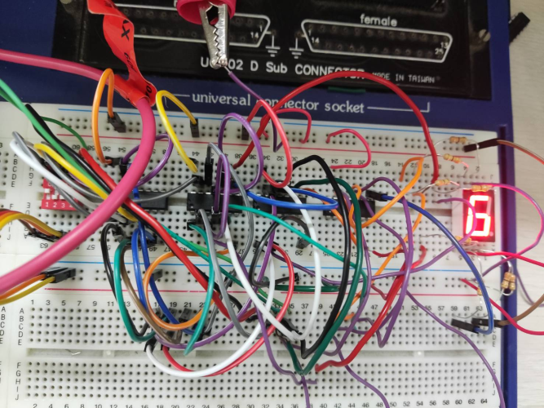

* + 1. (A,B,C,D)=(1,0,1,1)

1. Checking item(s)
   1. The IC is placed with the notch facing left, corresponding to the IC pin diagram, and each IC must be biased (VCC is connected to +5V, GND is connected to ground).
   2. When measuring voltage or current, start from the large scale, and then turn it down gradually to avoid damage to the meter.
2. Problem discussion:

In the process of designing and implementing the logic circuit for the seven-segment display, our team encountered some difficulties. The main issue was that the circuit was quite complex, and we made some errors while connecting the components. As a result, one of the segments on the display was showing the wrong output.

To solve this issue, we started by tracing back the circuit to the logic IC that was being used to control that particular segment. We then checked the connections and made sure that everything was correctly wired. We also tested the IC to make sure that it was functioning properly.

We discovered that the issue was not with the IC, but rather with a loose connection in one of the single-core wires. We fixed this by re-soldering the wire and ensuring that it was securely connected.

We also encountered some problems during the KMAP simplification process. At times, we made mistakes in grouping the variables, and this resulted in incorrect outputs. To address this, we carefully double-checked each step in the simplification process to ensure that we were not making any errors.

Overall, this experiment taught us the importance of being meticulous in our work and taking the time to double-check every step. We also learned that when working with complex circuits, it is essential to be patient and persistent in troubleshooting any issues that arise.

1. Review of experiment

B103015006 胡庭翊:

I found the experiment on designing and implementing the logic circuit for the seven-segment display to be a challenging but rewarding experience. I was particularly intrigued by the KMAP simplification process, which required us to group variables in a way that would minimize the number of logic gates needed to achieve the desired output.

The most challenging part of the experiment was connecting the components of the circuit. There were many wires to connect, and it was easy to make mistakes. However, with the help of my teammate, we were able to troubleshoot and correct any errors that we encountered.

One thing that I appreciated about this experiment was how it allowed us to apply the concepts that we learned in class to a practical application. It was satisfying to see the seven-segment display accurately showing the numbers corresponding to my student ID.

I also learned the importance of patience and perseverance when working on complex circuits. It can be frustrating when things don't work as expected, but with persistence and careful troubleshooting, we were able to identify and correct any issues that arose.

To conclude, I found this experiment to be a valuable learning experience, and I feel more confident in my ability to design and implement logic circuits.

B103015018 劉姵妤:

This experiment was a great opportunity for me to learn about the design and implementation of logic circuits using various electronic components. I was able to work collaboratively with my teammate and apply our combined knowledge to design a circuit that could display a specific subset of numbers and letters on the seven-segment display.

One of the challenges we faced was dealing with the complexity of the circuit, which led to some mistakes in the wiring and connections. Although it was frustrating at times, the process of identifying and fixing the errors was satisfying and helped me understand the importance of precision in electronics and win a sense of accomplishment. It was a great learning experience to identify the source of the problem and work together to troubleshoot and correct any errors that arose.

This experiment was a great way to gain practical skills and deepen my understanding of digital circuits. I'm grateful for the opportunity to work with my teammate and for the guidance of our TA throughout the experiment.